M. R. Hyker’s Latest Adventure

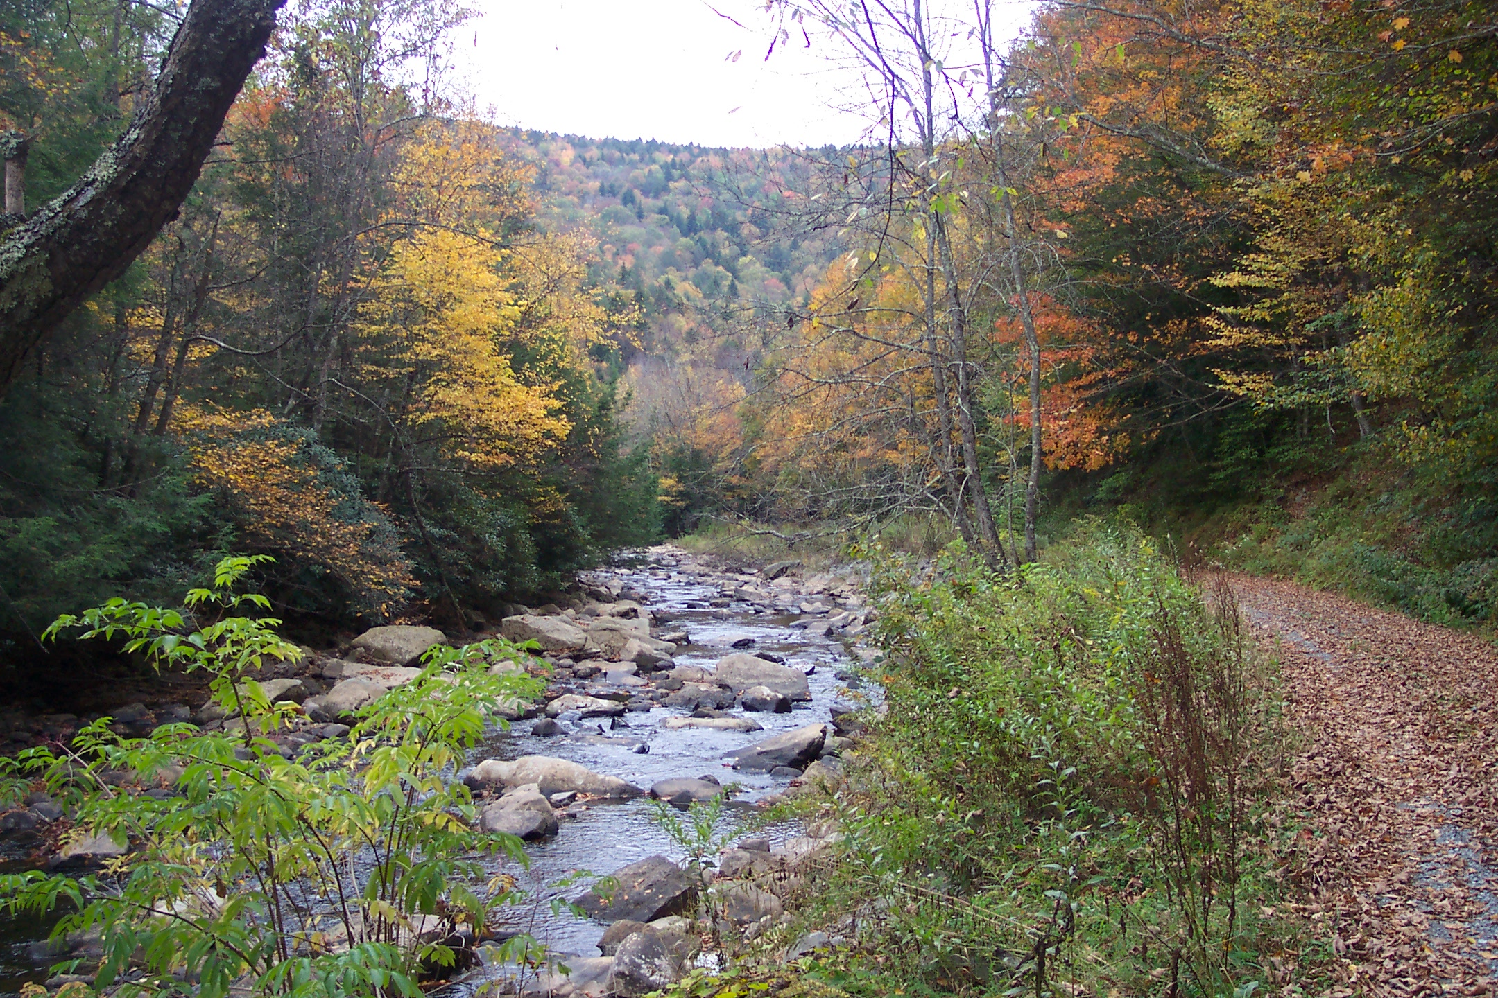

Oct 15th through Oct 17th: Cranberry Wilderness Backpack- First I need to thank two people: Dimitri Tundra, for sharing his knowledge of the Cranberry Wilderness with me as well as his maps and GPS Data (It made the outing easy.) and Susan Chappel who pre-scouted our first night's camp and lead us to it. Thank you both!
I've been wanting to hike the Cranberry for years. Unfortunately, most of the loops are quite long and the drive from Baltimore (6 hours) is way to much to consider when trying to do a day or over-night trip. Now that I've put on the ol' backpack I finally got the chance. On this I was joined by Hard Core, Ted E. Bear, Water Bug, Walker (Texas Ranger), Skywalker, Gear Girl, the Dough Boy and Sam the Wonder Dog. Susan joined us to take us to our first night's camp.
The hike down the North Fork Trail was both easy and rewarding. At higher elevations we walked through a beautiful Red Spruce Forest. As we dropped down into the valley the evergreens gave way to birch, cherry and oak. In a couple of miles the old forest road began to parallel the stream itself never leaving its banks again except to avoid a couple of blown-out spots along its bank. We made camp, a secluded spot hidden in a Rhododendron thicket right along the bank of the stream, around 5:00 o’clock. After taking a break Sue said good-bye and we continued setting up our tents and collecting fire wood. The high-lights of the evening were the tidbits of freshly baked pizza (Yes, made right at fire’s side, even making the dough from scratch) prepared by D.B. We spent the rest of the trip trying to develop a backpacking pizza oven to bring on the next trip. That night we were drenched by the light of a silver moon.

We hiked about 11 miles on the second day, first walking along FR76 and the very scenic Cranberry River and then climbing steeply up the Birch Log Trail to the North/South Trail. We turned east on that Ridge trail for about a mile and then descended on the Laurelly Trail to the Middle Fork of the Williams River. It was only about 3:30 when we reached the ford so hiked down to the confluence of Big Beechy Run and camped at that magnificent spot. Surprisingly, only a pair of backpackers was camped at a small site below the falls so we were able to spread out in an area big enough for several groups of hikers.

The real hallmark of the outing was the final day. We broke camp a little before 9:00 and followed an old railroad grade that paralleled the river and all of its rapids, falls and pools. About 2 miles up we startled a black bear which immediately shimmied up a tall tree. For some reason it immediately decided that was not the place to be and plunged head first to the ground with a thud, landing on its shoulder. Before we could respond it was back on its feet and charging up the very steep hill.

We hiked past Hell For Certain Run and then Slick Rock, a huge flat rock that runs about 30 yards down stream. Even though we were only about 1.5 miles from the cars we took a nice lunch at a small campsite just before the trail veered away from the river and climbed back up to meet the North Fork Trail. By 2:00 we had completed our little excursion and were back at the Cars. Next year will do another loop using the Big Beechy and Little Fork Trails to connect with the Middle Fork of the Williams River. I’m sure it will be just as scenic.

